# import the libraries

from datetime import timedelta

# The DAG object; we'll need this to instantiate a DAG

from airflow import DAG

# Operators; we need this to write tasks!

from airflow.operators.bash_operator import BashOperator

# This makes scheduling easy

from airflow.utils.dates import days_ago

#defining DAG arguments

# You can override them on a per-task basis during operator initialization

default_args = {

    'owner': 'Ram Param',

    'start_date': days_ago(0),

    'email': ['ramesh@somemail.com'],

    'email_on_failure': False,

    'email_on_retry': False,

    'retries': 0,

    'retry_delay': timedelta(seconds=2),

}

# defining the DAG

# define the DAG

dag = DAG(

    'etl_airflow',

    default_args=default_args,

    description='ETL pipeline text change',

    schedule_interval=timedelta(seconds=1),

)

# define the tasks

# define the first task         download task

'''

download = BashOperator(

    task_id='download',

    bash_command='wget "https://cf-courses-data.s3.us.cloud-object-storage.appdomain.cloud/IBM-DB0250EN-SkillsNetwork/labs/Apache%20Airflow/Build%20a%20DAG%20using%20Airflow/web-server-access-log.txt"',

    dag=dag,

)

'''

# define the second task        extract task

extract = BashOperator(

    task_id='extract',

    bash_command='cut -d "#" -f 1,4 /home/project/airflow/dags/web-server-access-log.txt > /home/project/airflow/dags/extracted-data_etl.txt',

    dag=dag,

)

# define the third task         transform task

transform = BashOperator(

    task_id='transform',

    bash_command='tr [:lower:] [:upper:] < /home/project/airflow/dags/extracted-data_etl.txt > /home/project/airflow/dags/transformed-data_etl.csv',

    dag=dag,

)

# define the fourth task        load task

load = BashOperator(

    task_id='load',

    bash_command='zip /home/project/airflow/dags/log.zip /home/project/airflow/dags/transformed-data_etl.csv',

    dag=dag,

)

# task pipeline

extract >> transform >> load

this time the 3rs task is failing again and again :-

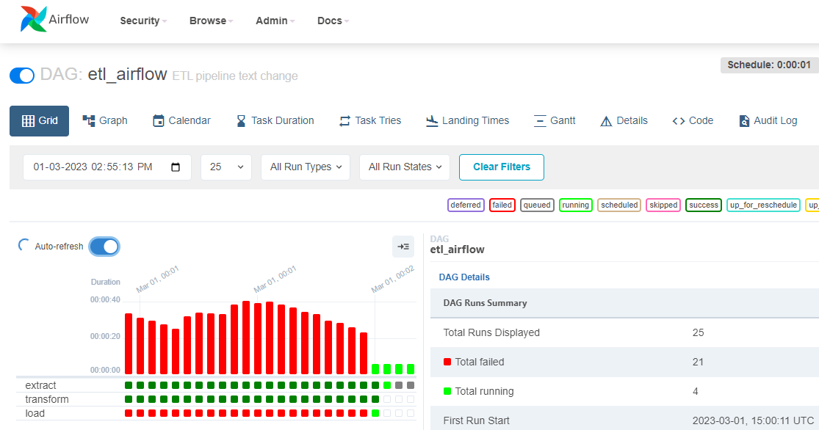

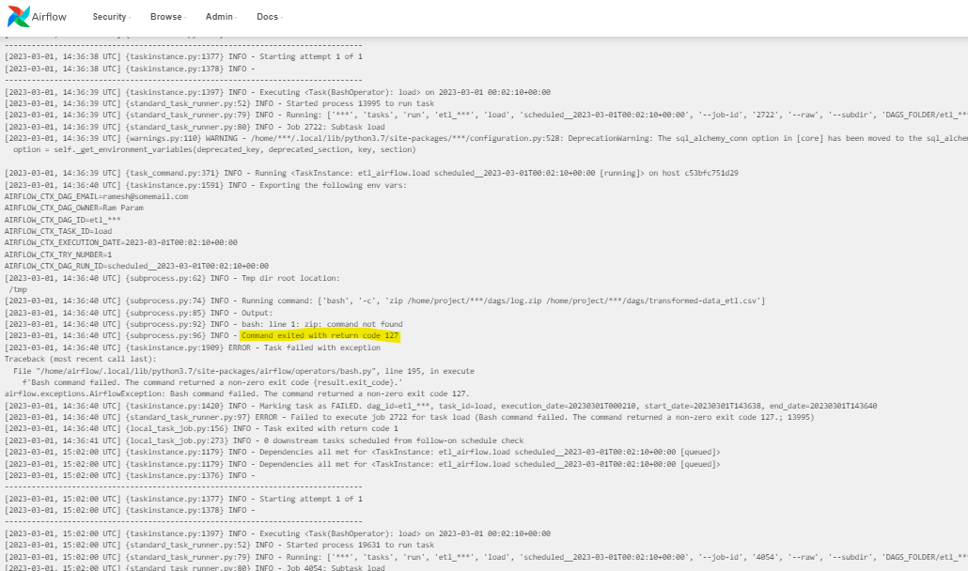

Below is the log in text for last task :-

*** Reading local file: /home/project/airflow/logs/dag_id=etl_airflow/run_id=scheduled__2023-03-01T00:02:10+00:00/task_id=load/attempt=1.log

[2023-03-01, 14:36:38 UTC] {taskinstance.py:1179} INFO - Dependencies all met for <TaskInstance: etl_airflow.load scheduled__2023-03-01T00:02:10+00:00 [queued]>

[2023-03-01, 14:36:38 UTC] {taskinstance.py:1179} INFO - Dependencies all met for <TaskInstance: etl_airflow.load scheduled__2023-03-01T00:02:10+00:00 [queued]>

[2023-03-01, 14:36:38 UTC] {taskinstance.py:1376} INFO -

--------------------------------------------------------------------------------

[2023-03-01, 14:36:38 UTC] {taskinstance.py:1377} INFO - Starting attempt 1 of 1

[2023-03-01, 14:36:38 UTC] {taskinstance.py:1378} INFO -

--------------------------------------------------------------------------------

[2023-03-01, 14:36:39 UTC] {taskinstance.py:1397} INFO - Executing <Task(BashOperator): load> on 2023-03-01 00:02:10+00:00

[2023-03-01, 14:36:39 UTC] {standard_task_runner.py:52} INFO - Started process 13995 to run task

[2023-03-01, 14:36:39 UTC] {standard_task_runner.py:79} INFO - Running: ['***', 'tasks', 'run', 'etl_***', 'load', 'scheduled__2023-03-01T00:02:10+00:00', '--job-id', '2722', '--raw', '--subdir', 'DAGS_FOLDER/etl_***.py', '--cfg-path', '/tmp/tmpy12bzk5o', '--error-file', '/tmp/tmpvhkxgpmm']

[2023-03-01, 14:36:39 UTC] {standard_task_runner.py:80} INFO - Job 2722: Subtask load

[2023-03-01, 14:36:39 UTC] {warnings.py:110} WARNING - /home/***/.local/lib/python3.7/site-packages/***/configuration.py:528: DeprecationWarning: The sql_alchemy_conn option in [core] has been moved to the sql_alchemy_conn option in [database] - the old setting has been used, but please update your config.

option = self._get_environment_variables(deprecated_key, deprecated_section, key, section)

[2023-03-01, 14:36:39 UTC] {task_command.py:371} INFO - Running <TaskInstance: etl_airflow.load scheduled__2023-03-01T00:02:10+00:00 [running]> on host c53bfc751d29

[2023-03-01, 14:36:40 UTC] {taskinstance.py:1591} INFO - Exporting the following env vars:

AIRFLOW_CTX_DAG_EMAIL=ramesh@somemail.com

AIRFLOW_CTX_DAG_OWNER=Ram Param

AIRFLOW_CTX_DAG_ID=etl_***

AIRFLOW_CTX_TASK_ID=load

AIRFLOW_CTX_EXECUTION_DATE=2023-03-01T00:02:10+00:00

AIRFLOW_CTX_TRY_NUMBER=1

AIRFLOW_CTX_DAG_RUN_ID=scheduled__2023-03-01T00:02:10+00:00

[2023-03-01, 14:36:40 UTC] {subprocess.py:62} INFO - Tmp dir root location:

/tmp

[2023-03-01, 14:36:40 UTC] {subprocess.py:74} INFO - Running command: ['bash', '-c', 'zip /home/project/***/dags/log.zip /home/project/***/dags/transformed-data_etl.csv']

[2023-03-01, 14:36:40 UTC] {subprocess.py:85} INFO - Output:

[2023-03-01, 14:36:40 UTC] {subprocess.py:92} INFO - bash: line 1: zip: command not found

[2023-03-01, 14:36:40 UTC] {subprocess.py:96} INFO - Command exited with return code 127

[2023-03-01, 14:36:40 UTC] {taskinstance.py:1909} ERROR - Task failed with exception

Traceback (most recent call last):

File "/home/airflow/.local/lib/python3.7/site-packages/airflow/operators/bash.py", line 195, in execute

f'Bash command failed. The command returned a non-zero exit code {result.exit_code}.'

airflow.exceptions.AirflowException: Bash command failed. The command returned a non-zero exit code 127.

[2023-03-01, 14:36:40 UTC] {taskinstance.py:1420} INFO - Marking task as FAILED. dag_id=etl_***, task_id=load, execution_date=20230301T000210, start_date=20230301T143638, end_date=20230301T143640

[2023-03-01, 14:36:40 UTC] {standard_task_runner.py:97} ERROR - Failed to execute job 2722 for task load (Bash command failed. The command returned a non-zero exit code 127.; 13995)

[2023-03-01, 14:36:40 UTC] {local_task_job.py:156} INFO - Task exited with return code 1

[2023-03-01, 14:36:41 UTC] {local_task_job.py:273} INFO - 0 downstream tasks scheduled from follow-on schedule check

[2023-03-01, 15:02:00 UTC] {taskinstance.py:1179} INFO - Dependencies all met for <TaskInstance: etl_airflow.load scheduled__2023-03-01T00:02:10+00:00 [queued]>

[2023-03-01, 15:02:00 UTC] {taskinstance.py:1179} INFO - Dependencies all met for <TaskInstance: etl_airflow.load scheduled__2023-03-01T00:02:10+00:00 [queued]>

[2023-03-01, 15:02:00 UTC] {taskinstance.py:1376} INFO -

--------------------------------------------------------------------------------

[2023-03-01, 15:02:00 UTC] {taskinstance.py:1377} INFO - Starting attempt 1 of 1

[2023-03-01, 15:02:00 UTC] {taskinstance.py:1378} INFO -

--------------------------------------------------------------------------------

[2023-03-01, 15:02:00 UTC] {taskinstance.py:1397} INFO - Executing <Task(BashOperator): load> on 2023-03-01 00:02:10+00:00

[2023-03-01, 15:02:00 UTC] {standard_task_runner.py:52} INFO - Started process 19631 to run task

[2023-03-01, 15:02:00 UTC] {standard_task_runner.py:79} INFO - Running: ['***', 'tasks', 'run', 'etl_***', 'load', 'scheduled__2023-03-01T00:02:10+00:00', '--job-id', '4054', '--raw', '--subdir', 'DAGS_FOLDER/etl_***.py', '--cfg-path', '/tmp/tmp1zlyn6gz', '--error-file', '/tmp/tmpb1uzqh7w']

[2023-03-01, 15:02:00 UTC] {standard_task_runner.py:80} INFO - Job 4054: Subtask load

[2023-03-01, 15:02:00 UTC] {warnings.py:110} WARNING - /home/***/.local/lib/python3.7/site-packages/***/configuration.py:528: DeprecationWarning: The sql_alchemy_conn option in [core] has been moved to the sql_alchemy_conn option in [database] - the old setting has been used, but please update your config.

option = self._get_environment_variables(deprecated_key, deprecated_section, key, section)

[2023-03-01, 15:02:00 UTC] {task_command.py:371} INFO - Running <TaskInstance: etl_airflow.load scheduled__2023-03-01T00:02:10+00:00 [running]> on host c53bfc751d29

[2023-03-01, 15:02:01 UTC] {taskinstance.py:1591} INFO - Exporting the following env vars:

AIRFLOW_CTX_DAG_EMAIL=ramesh@somemail.com

AIRFLOW_CTX_DAG_OWNER=Ram Param

AIRFLOW_CTX_DAG_ID=etl_***

AIRFLOW_CTX_TASK_ID=load

AIRFLOW_CTX_EXECUTION_DATE=2023-03-01T00:02:10+00:00

AIRFLOW_CTX_TRY_NUMBER=1

AIRFLOW_CTX_DAG_RUN_ID=scheduled__2023-03-01T00:02:10+00:00

[2023-03-01, 15:02:01 UTC] {subprocess.py:62} INFO - Tmp dir root location:

/tmp

[2023-03-01, 15:02:01 UTC] {subprocess.py:74} INFO - Running command: ['bash', '-c', 'zip /home/project/***/dags/log.zip /home/project/***/dags/transformed-data_etl.csv']

[2023-03-01, 15:02:01 UTC] {subprocess.py:85} INFO - Output:

[2023-03-01, 15:02:01 UTC] {subprocess.py:92} INFO - bash: line 1: zip: command not found

[2023-03-01, 15:02:01 UTC] {subprocess.py:96} INFO - Command exited with return code 127

[2023-03-01, 15:02:01 UTC] {taskinstance.py:1909} ERROR - Task failed with exception

Traceback (most recent call last):

File "/home/airflow/.local/lib/python3.7/site-packages/airflow/operators/bash.py", line 195, in execute

f'Bash command failed. The command returned a non-zero exit code {result.exit_code}.'

airflow.exceptions.AirflowException: Bash command failed. The command returned a non-zero exit code 127.

[2023-03-01, 15:02:01 UTC] {taskinstance.py:1420} INFO - Marking task as FAILED. dag_id=etl_***, task_id=load, execution_date=20230301T000210, start_date=20230301T150200, end_date=20230301T150201

[2023-03-01, 15:02:01 UTC] {standard_task_runner.py:97} ERROR - Failed to execute job 4054 for task load (Bash command failed. The command returned a non-zero exit code 127.; 19631)

[2023-03-01, 15:02:01 UTC] {local_task_job.py:156} INFO - Task exited with return code 1

[2023-03-01, 15:02:01 UTC] {local_task_job.py:273} INFO - 0 downstream tasks scheduled from follow-on schedule check